The North Texas Saluki Club
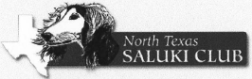

2019 Fort Worth Specialties and Sweepstakes

March 22, 23 and 24 (Friday, Saturday and Sunday)

- Friday a.m. Specialty Judge - Gretchen Bernardi (Illinois)
- Friday p.m. Sweepstakes Judge - Brenda Brody
- Friday p.m. Specialty Judge - Juan Miranda (Mexico)
- 4-6 Month Puppy Competition on Friday
- Junior Handler Competition on Friday - $100.00 Gift Card for the Winner
- Saturday Sweepstakes Judge – Samantha Newton

Superintendent is Onofrio. Entries close Wednesday, March 6, 2019.

